# Azure Databricks

Azure Databricks is a fast, easy, and collaborative Apache Spark–based analytics platform optimized for Microsoft Azure. It provides a unified environment where data engineers, data scientists, and business analysts can collaborate to process massive amounts of data, build AI/ML models, and derive actionable insights. This guide provides a structured overview of Azure Databricks, its architecture, features, and use cases.

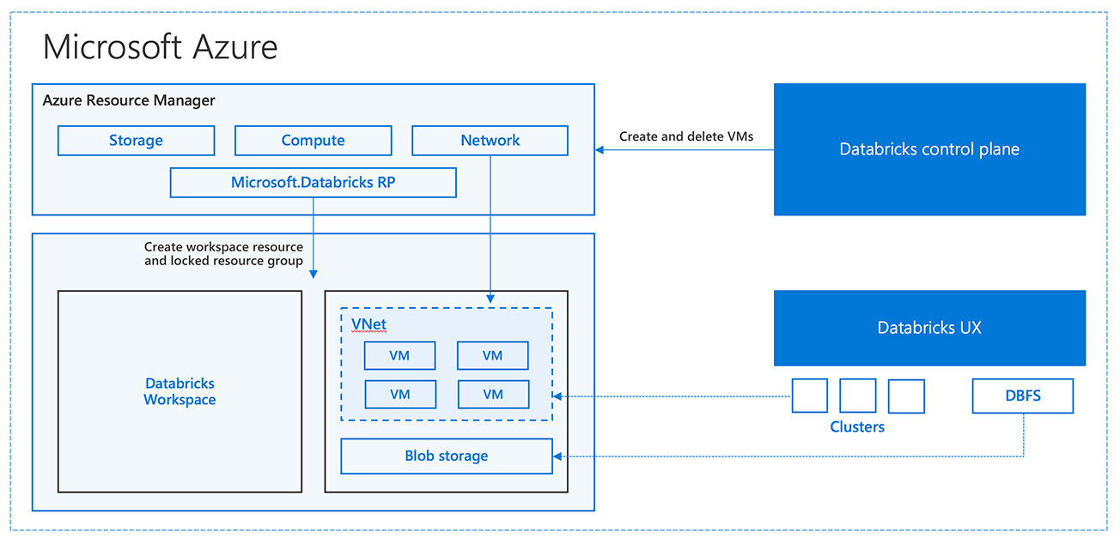

## What is Azure Databricks?

Azure Databricks is an integrated data analytics service that accelerates innovation by combining the best of Databricks and Azure. It offers a collaborative workspace powered by Apache Spark for big data processing, machine learning, real-time analytics, and business intelligence. It allows seamless integration with Azure services such as Data Lake, Synapse Analytics, Azure Machine Learning, and Power BI.

## Key Features of Azure Databricks

Some of the most powerful features of Azure Databricks include:

* Scalability: Handle petabytes of data with auto-scaling clusters.
* Collaboration: Shared workspace for data engineers, analysts, and data scientists.
* Machine Learning Integration: Build, train, and deploy ML models using MLflow.
* Seamless Azure Integration: Works natively with Azure services like Data Lake and Synapse.
* Security: Enterprise-grade compliance, role-based access, and secure networking.
* Optimized Apache Spark: High performance through Delta Lake and optimized connectors.

## Architecture Overview

Azure Databricks uses a highly scalable architecture built on Apache Spark. It consists of a control plane and a data plane.  
- The control plane manages cluster configuration, notebooks, jobs, and collaboration features.  
- The data plane executes Spark jobs and manages data storage and compute.  
This architecture ensures efficiency, scalability, and security for handling enterprise-level workloads.

## Use Cases

Azure Databricks is widely used across industries. Common use cases include:

* Data Engineering: ETL pipelines for structured and unstructured data.
* Machine Learning: Training and deploying ML models at scale.
* Real-time Analytics: Stream processing for IoT and event-driven data.
* Business Intelligence: Connecting with Power BI for rich visualizations.
* Genomics and Healthcare: Large-scale bioinformatics data processing.

## Advantages of Azure Databricks

- Unified Platform: Combines data engineering, analytics, and machine learning.  
- Productivity Boost: Notebooks and collaboration tools streamline workflows.  
- Cost Efficiency: Auto-scaling reduces resource wastage.  
- Enterprise-Grade Security: Ensures compliance with HIPAA, GDPR, and other standards.  
- Flexibility: Supports multiple languages (Python, Scala, R, SQL) and frameworks.

## Getting Started with Azure Databricks

To begin with Azure Databricks:  
1. Create an Azure Databricks workspace from the Azure portal.  
2. Launch the workspace and create a new cluster.  
3. Import data into the workspace using Azure Data Lake or Blob Storage.  
4. Create and run notebooks using Python, R, or SQL.  
5. Connect with Power BI or Azure ML for visualization and advanced modeling.

## Conclusion

Azure Databricks empowers organizations to accelerate their data-driven journey by offering a powerful, collaborative, and scalable environment for analytics and AI. Its deep integration with Azure services, enterprise security, and robust features make it a top choice for businesses aiming to unlock the full potential of their data. Whether it is real-time analytics, data engineering, or machine learning, Azure Databricks stands as a comprehensive solution.